Lab 4

Exercise 1:
Part 1

#include <stdafx.h>
#include <iostream>
#include <fstream>
using namespace std;

int main()
{

ifstream infile; // ifstream is a data type
// ifstream = Input file stream
infile.open("data1.txt"); //open data file named 'datafile1.txt'
int temp = 0;

while(!infile.eof()) // while the input file, 'infile' is not at the
{ // End Of File (eof)

infile>>temp; // load the variable 'temp'
cout<<temp<<endl; // display the variable temp to the screen
}

infile.close(); // close the input file

system("pause");
return 0;
}
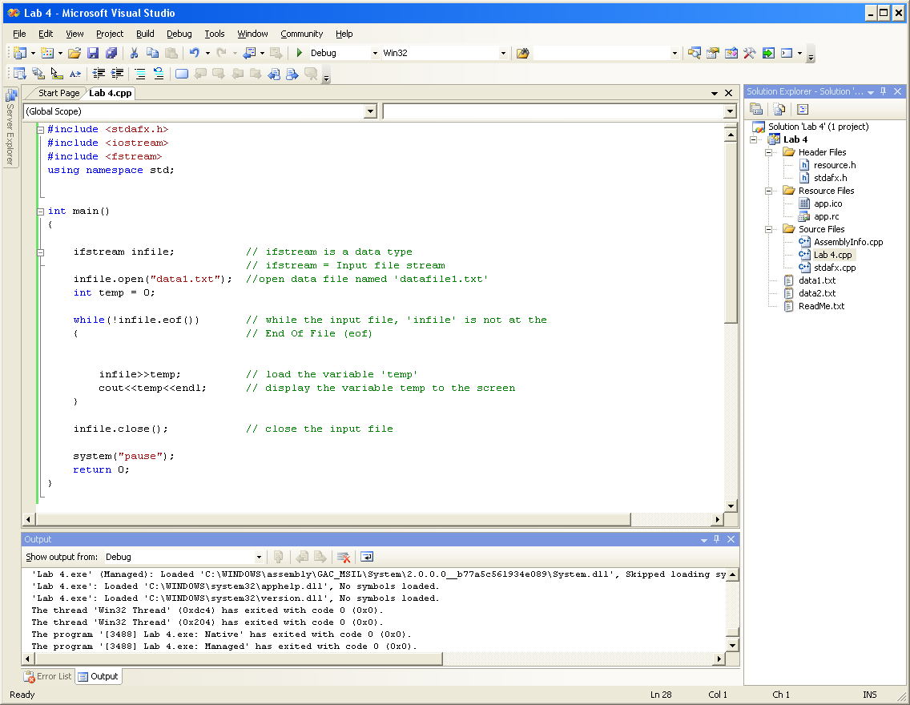

Part 2 data1.txt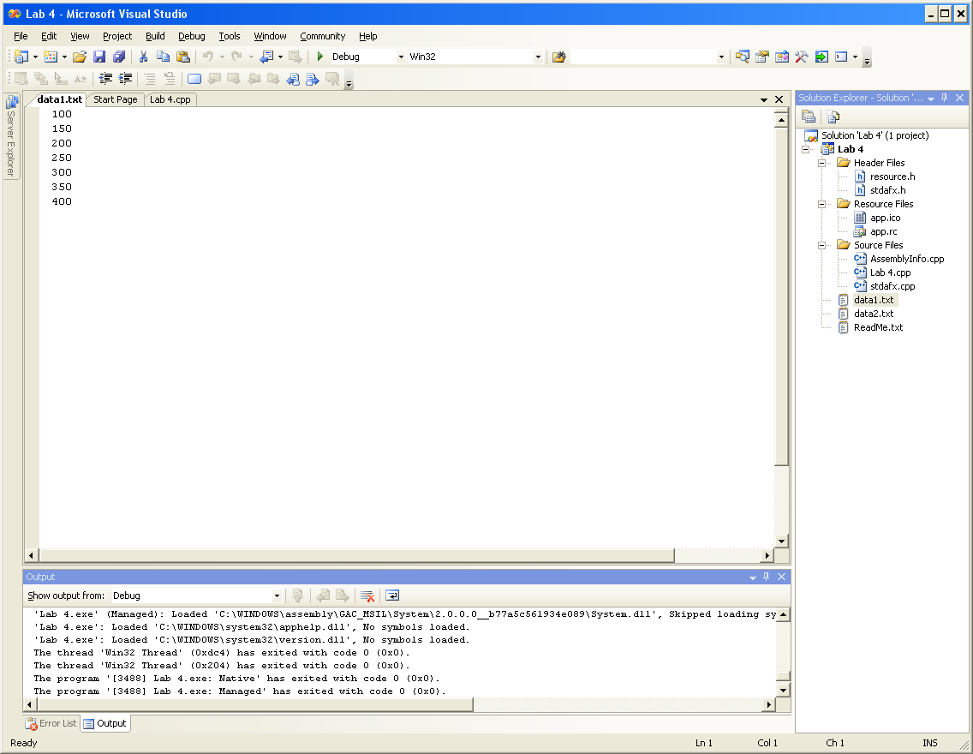

data2.txt
Part3: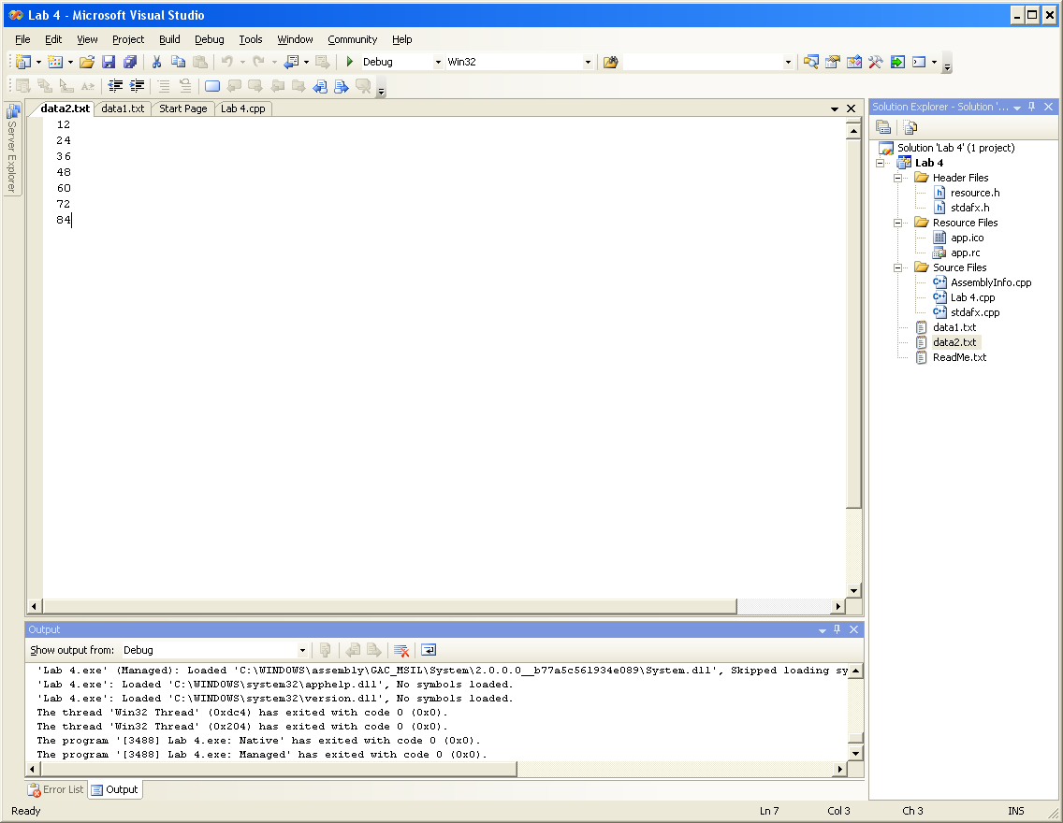

infile is of file type: text file.

Part 4:

#include <stdafx.h>
#include <iostream>
#include <fstream>
using namespace std;

int main()
{

ifstream infile; // ifstream is a data type
// ifstream = Input file stream
infile.open("data1.txt"); //open data file named 'datafile1.txt'
int temp = 0;

while(!infile.eof()) // while the input file, 'infile' is not at the
{ // End Of File (eof)

infile>>temp; // load the variable 'temp'
cout<<temp<<endl; // display the variable temp to the screen
}

infile.close(); // close the input file

system("pause");
return 0;
}

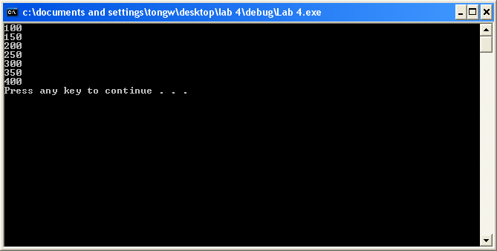

The output matches that of data1.txt.

#include <stdafx.h>
#include <iostream>
#include <fstream>
using namespace std;

int main()
{

ifstream infile; // ifstream is a data type
// ifstream = Input file stream
infile.open("data2.txt"); //open data file named 'datafile1.txt'
int temp = 0;

while(!infile.eof()) // while the input file, 'infile' is not at the
{ // End Of File (eof)

infile>>temp; // load the variable 'temp'
cout<<temp<<endl; // display the variable temp to the screen
}

infile.close(); // close the input file

system("pause");
return 0;
}

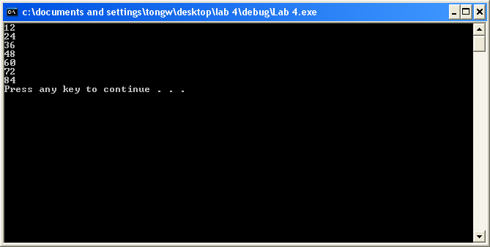

Part 5:

#include <stdafx.h>
#include <iostream>
#include <fstream>
using namespace std;

int main()
{

ifstream infile; // ifstream is a data type
// ifstream = Input file stream
infile.open("data3.txt"); //open data file named 'datafile1.txt'
int temp = 0;

while(!infile.eof()) // while the input file, 'infile' is not at the
{ // End Of File (eof)

infile>>temp; // load the variable 'temp'
cout<<temp<<endl; // display the variable temp to the screen
}

infile.close(); // close the input file

system("pause");
return 0;
}
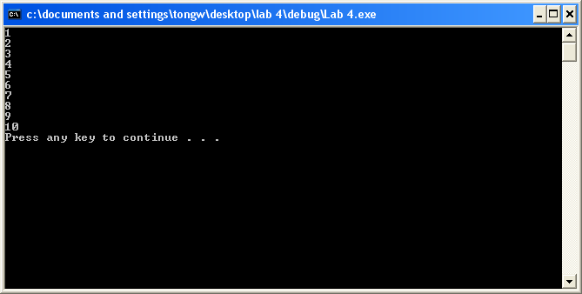

The output matches that of the file that was just created.

Part 6:

#include <stdafx.h>
#include <iostream>
#include <fstream>
#include <ostream>
using namespace std;

int main()
{
ofstream outfile;
ifstream infile1;
ifstream infile2;
ifstream infile3; // ifstream is a data type
// ifstream = Input file stream
infile1.open("data1.txt"); //open data file named 'datafile1.txt'
infile2.open("data2.txt");
infile3.open("data3.txt");
outfile.open("outdata.txt");
int temp = 0;

while(!infile1.eof()) // while the input file, 'infile' is not at the
{ // End Of File (eof)

infile1 >> temp; // load the variable 'temp'
cout << temp <<endl; // display the variable temp to the screen

outfile << temp <<endl;
}

while(!infile2.eof()) // while the input file, 'infile' is not at the
{ // End Of File (eof)

infile2 >> temp; // load the variable 'temp'
cout << temp <<endl; // display the variable temp to the screen

outfile << temp <<endl;
}

while(!infile3.eof()) // while the input file, 'infile' is not at the
{ // End Of File (eof)

infile3 >> temp; // load the variable 'temp'
cout << temp <<endl; // display the variable temp to the screen

outfile << temp <<endl;
}
infile1.close(); // close the input file
infile2.close();
infile3.close();
outfile.close();

system("pause");
return 0;
}
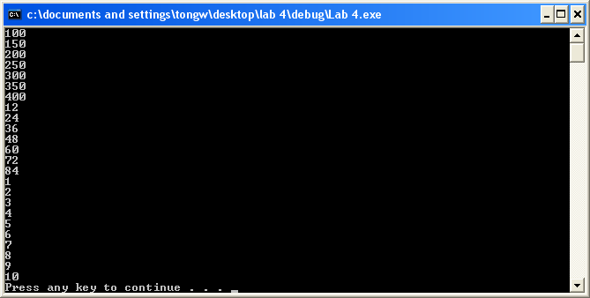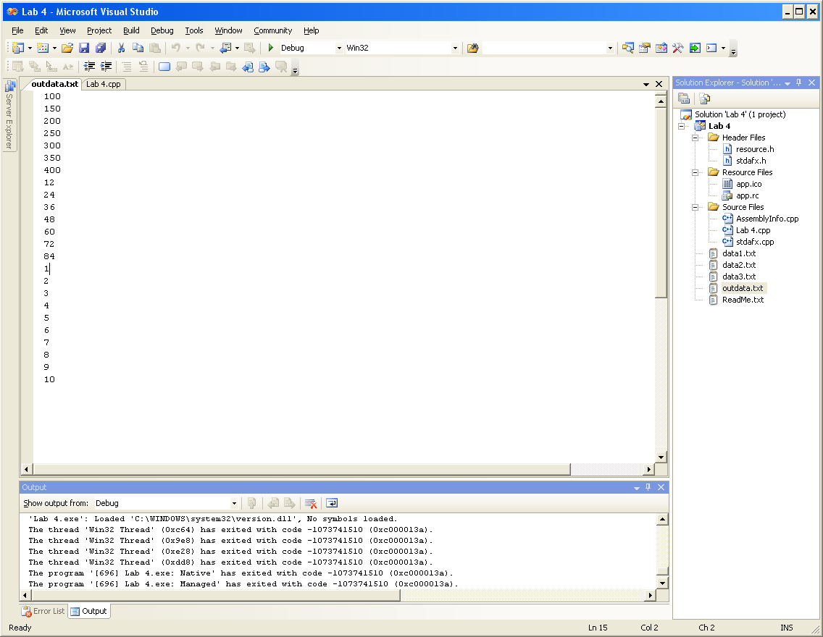

Modifying the code will lead to difference outputs:
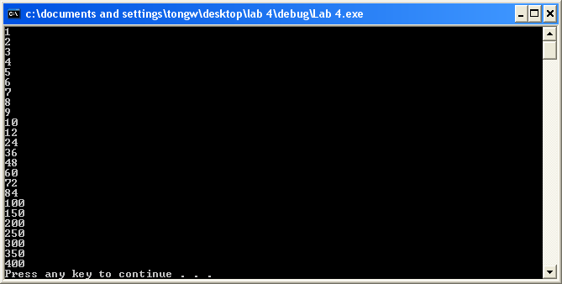
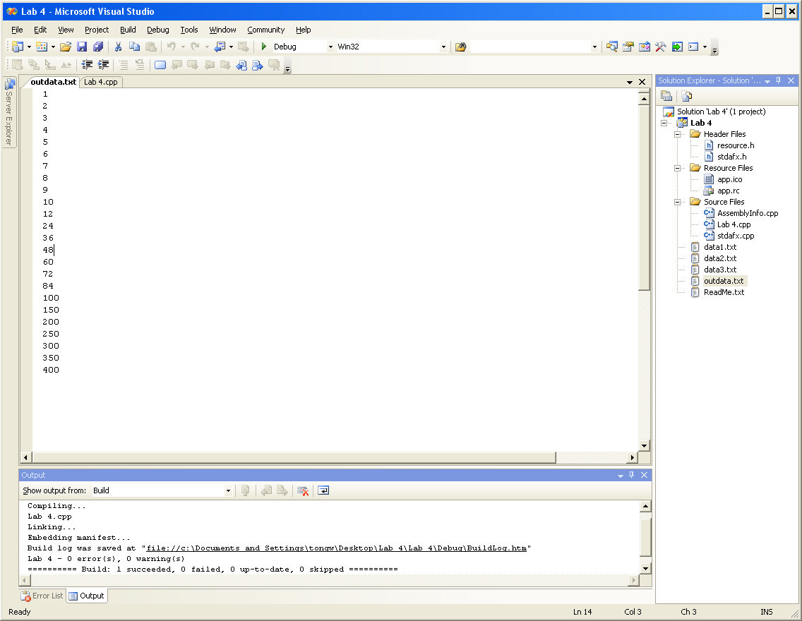

Exercise 2:

Parts 1, 2, 3 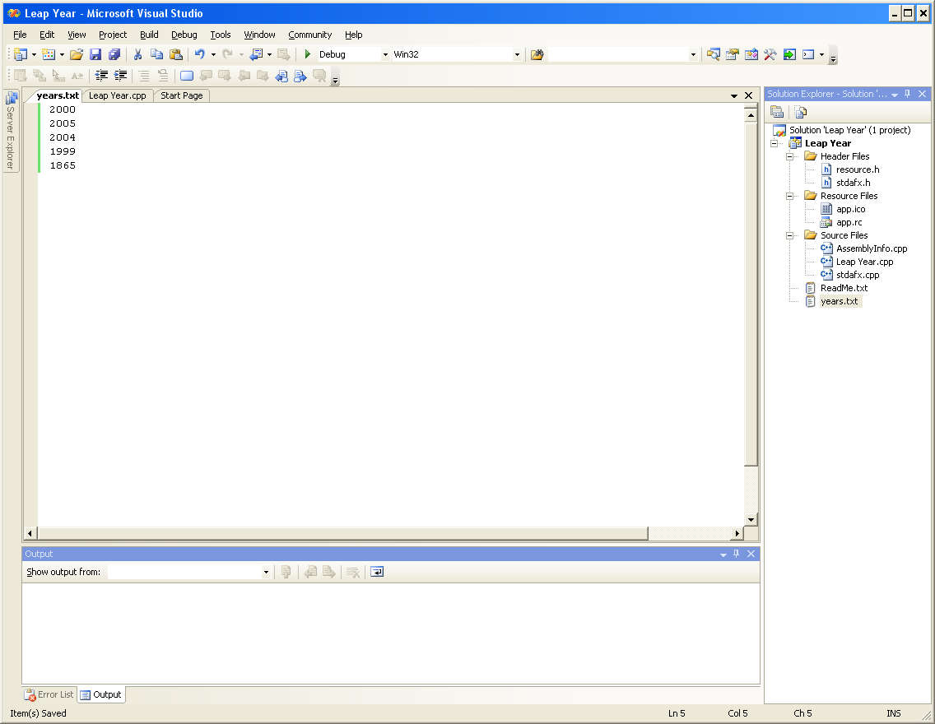

#include "stdafx.h"
#include <iostream>
#include <fstream> //for filestream data
using namespace std;

bool isLeapYear( int year ); //prototype for Boolean function

int main()
{

ifstream yearFile;
int theYear = 0;

yearFile.open("years.txt");

while(!yearFile.eof())
{
yearFile >> theYear;

if(isLeapYear(theYear))
cout << theYear << " is a leap year." << endl;
else
cout << theYear << " is not a leap year." << endl;

}
// Add code here to * LOOP * through the different years
// and determine if each year is a leap year or not
// if it is, print out "the year <the actual year> is a leap year"
// if it is not, print out "the year <the actual year> is NOT a leap year"
// PRINT to the monitor / console

yearFile.close();

return 0;
}

// ----- determine whether an input YEAR is a leap year or not
bool isLeapYear( int year )
{
if (year % 4 !=0)
{
//if NOT divisible by 4, it is not a leap year
return false;
}
else if (year % 100 != 0) //year IS divisible by 4, AND NOT by 100
{
return true;
}
else if (year % 400 != 0) //year NOT divisible by 400
{
return false;
}
else
{
return true;
}

}
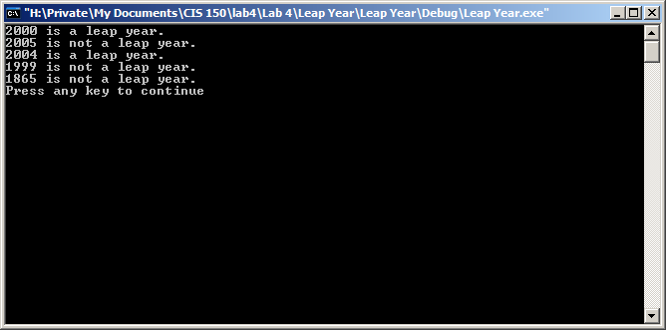

For some reason, the file still executed and performed the operations correctly, but I think it would be more appropriate to change the name ‘year’ to ‘theYear’? :

#include "stdafx.h"
#include <iostream>
#include <fstream> //for filestream data
using namespace std;

bool isLeapYear( int theYear ); //prototype for Boolean function

int main()
{

ifstream yearFile;
int theYear = 0;

yearFile.open("years.txt");

while(!yearFile.eof())
{
yearFile >> theYear;

if(isLeapYear(theYear))
cout << theYear << " is a leap year." << endl;
else
cout << theYear << " is not a leap year." << endl;

}
// Add code here to * LOOP * through the different years
// and determine if each year is a leap year or not
// if it is, print out "the year <the actual year> is a leap year"
// if it is not, print out "the year <the actual year> is NOT a leap year"
// PRINT to the monitor / console

yearFile.close();

return 0;
}

// ----- determine whether an input theYear is a leap theYear or not
bool isLeapYear( int theYear )
{
if (theYear % 4 !=0)
{
//if NOT divisible by 4, it is not a leap theYear
return false;
}
else if (theYear % 100 != 0) //theYear IS divisible by 4, AND NOT by 100
{
return true;
}
else if (theYear % 400 != 0) //theYear NOT divisible by 400
{
return false;
}
else
{
return true;
}

}

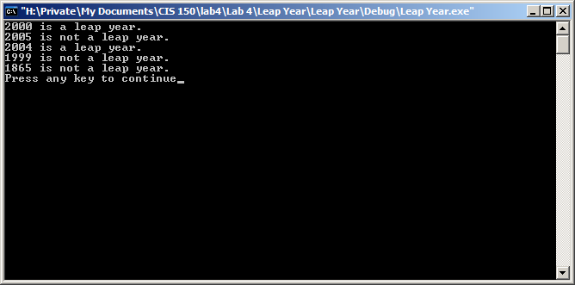

They seem to do the same thing.

